Shabbos Stories for
Rosh hashanah 5781
Volume 12, Issue 1 1-2 Tishrei/ Sept. 19-20, 2020
Printed L’illuy nishmas Nechama bas R’ Noach, a”h

For a free subscription, please forward your request to keren18@juno.com

How I Will Celebrate
Rosh Hashanah Alone
By Karen Kaplan

I love the High Holidays—the month when we turn our full attention to G-d, reflect upon our renewed commitment to becoming our best selves, and spend time with our family and friends.
Except this year. This year is different. This year there is the pandemic.
I’m an older woman, living alone, with health issues, and for those like me, this year will be unlike any before. I'll be observing the holidays at home, by myself.
I’m used to davening at my local Chabad center, listening as the chazzan (cantor) does the “heavy lifting” of reciting the prayers, allowing my mind to wander at will, letting the rabbi make the service meaningful with his commentary, listening as the shofar is blown.
During services, I was more like a passenger than a driver. I got to look out the window and enjoy the scenery because I didn't have to drive the car. This year everything will be different.

Does Different Have to Mean Bad?
But does different have to mean bad? Can’t something be different and good? I like to eat coffee ice cream every day, but if there’s none in the freezer, I'll eat vanilla instead. And maybe that vanilla will be a delicious change.
So, I decided to look for new ways to make this year fresh and exciting. And truly, shouldn’t we be doing this every year? Each year we stand before G-d, asking Him to forgive our shortcomings, asking Him to view us favorably, asking Him to give us another year to grow and improve. Should this ever be done on autopilot?
It’s true, we are living in difficult times. But Chassidic tradition teaches that all experiences - even the difficult ones - are opportunities to reveal the goodness that exists within everything. G-d put goodness in all His creations, but we have to choose to look for it. Sometimes it’s easy, sometimes it’s hard, but it’s always our choice.
This year I’ve been forced out of my comfort zone by circumstances I can’t control. Even if I wanted to, I can’t go on autopilot. I can’t sit back, enjoy the ride, and let someone else drive the car. I’m behind the wheel. But being the driver means that I’ll be in control of the journey. And that, I believe, is where the goodness lies within this very different holiday season. I will control the journey, and I am choosing to take the scenic route.

Slow Down and Sing
When I’m in shul, I have to rush through the prayers just to keep up. I’m looking forward to going at my own pace and taking time to think about what I’m reading. I’ve also started listening to musical renditions of the prayers we sing (you can find excellent ones on Chabad.org) to learn the melodies.
I’ve called my local Judaica store and bought a shofar. My very own shofar! Blowing it is not as hard as I'd thought and I have the entire month of Elul to practice. By Rosh Hashanah, I'll be ready to crown the King!
It will be hard not being with my friends during the festive meals, and nothing can replace that, but I'll make sure I have good company in the form of uplifting Jewish books. I've collected many excellent ones over the years, and my bookcases make me feel like the greatest Jewish minds in history are in the room with me, ready to teach and converse. The Lubavitcher Rebbe may join me for lunch, Maimonides for dinner, and the Baal Shem Tov (founder of Chassidism) for coffee the next morning. And of course, I'll have books of Chassidic stories to spice up the meal. With guests like these, I'll naturally want to put on nice clothes and set the table with my best things.
Yes, this year will be different. I’ve been given my driver’s license and handed the car keys. I can't wait to get out on the road, open the windows, and enjoy the ride. May your own journey this season be healthy, smooth, and meaningful.

Weekly Chasidic Story #1082
Foiling the Third Decree
From the desk of Yerachmiel Tilles

In the little town of Lubavitch, the month of Elul was drawing to a close. The wind of teshuva had blown through the village for thirty days, aiding everyone in perfecting their spiritual service. More Tehillim (reciting Psalms), more Tzedakah (charity), more Torah study. The frenzied preparation reached its climax.
The setting sun signaled the beginning of a new year when the Creator sits in judgment and decides the affairs of every individual. Many thousands of chasidim poured into the village, eager to spend Rosh HaShana with the Tzemach Tzedek. They crammed into the Rebbe's shul, filling the huge interior until nary an empty inch remained.

A Hush Fell on the Room
A hush fell on the room as the Tzemach Tzedek entered. A path miraculously appeared. The Rebbe made his way to his place, and Rosh Hashana evening prayer began.
It was an unusual Maariv. The Tzemach Tzedek appeared drawn, worried. His prayers were imbued with extraordinary fervor, as though - if it were possible - they were more fervent than an ordinary Rosh HaShana.
Fear and dread gripped every heart. This is the time when "the angels tremble, terror seizes them, and they exclaim: 'The Day of Judgment is here.'" The chasidim redoubled their concentration, desperately trying to arouse divine mercy. Everyone felt that something unusual was in the air.
That night after the prayers, the Rebbe joined his family for the holiday meal. Though the Lubavitch Rebbes generally minimized all talk on Rosh HaShana, the Tzemach Tzedek distinctively made it a point to speak during the meal every Rosh HaShana. He discussed current events in the capital, the names and ranks of different ministers and the political situation in general. Reb Yehuda-Leib, one of the Rebbe's sons, would remark, "He is performing Baalshem'ske (Baal Shem Tov style) wonders in Petersburg right now."

This Year Was No Different
This year was no different. The Tzemach Tzedek related all the goings-on in the capital and focused on certain ministers and their roles. In fact, he seemed more specific, more detailed, than in other years. His sons listened quietly, as they always did, taking notice of the Rebbe's particular emphasis in the discussion.
The day of Rosh HaShana dawned and throngs of Chassidim streamed toward the Rebbe's shul. Again the Rebbe's prayers were permeated with emotion. After the morning prayer was completed and the Torah reading was finished, everyone prepared themselves for the great mitzvah of shofar.
A feeling of awe enveloped the large synagogue as the seven sons of the Tzemach Tzedek took their places around the platform, each in his designated place. The Tzemach Tzedek himself finished his preparations, readying himself to blow the thirty notes. His face burned brightly as he sang softly to himself, his eyes closed in deep concentration. Suddenly his voice resonated throughout the shul, "Ay, sertzeh, LaMnatzei'ach…" ("Woe! My heart! A Psalm…").

Panic Gripped the Congregation
Panic gripped the congregation and tears flowed from every eye. Some evil decree prompted the Rebbe's unusual outburst, no doubt, and a great wailing filled the shul. Everyone's heart was open, raw and receptive. The congregation recited Psalm 47 seven times as required and the Rebbe began the required sounds.

* * *
Minister Suvorin, governor of Petersburg, the capital, studied his reflection in the ornate mirror gracing the walls of the czar's antechamber. He was waiting somewhat impatiently for his scheduled appointment with His Majesty. In his hand lay the document in which he had invested so much work. It concerned the so-called great rabbi, M. M. Schneersohn, the one they called "Tzemach Tzedek."
A flicker of annoyance crossed his face. It was intolerable that a rabbi should have all that power, what with all his followers and students spread across White Russia. His seat of power lay in his choice of residence, a small village far away from prying eyes and government informers.

Forced to Move to Either Petersburg or Kiev
No more. The rabbi would now be forced to move to either Petersburg or Kiev. His followers would think twice before visiting their rabbi in such a large city. They would be too easily followed, easily questioned, easily inspected. He had the official document in his hand now: all it needed was the czar's signature.
Suvorin crossed the magnificent antechamber and stared pensively out the window. A fair portion of Petersburg was visible from here. There had been some trouble lately - anger was brewing among the populace, and he knew he was mostly to blame. His two new decrees had raised the ire of Petersburg's residents, but they were just a mob of common folk anyway. After all, his intentions had been pure.
He turned from the window and paced the room, smiling as he recalled the new decrees. No smoking was allowed on city streets. It was untidy; too many cigarette butts were allowed to litter the city. No more meat would be sold within the city. Whoever wanted meat would have to go out of the city and buy it there. No longer would the beautiful capital carry the smell of rotting flesh. With these two decrees, he, Minister Suvorin, had launched his campaign to make Petersburg the most beautiful capital in the world.

“His Majesty Will See You Now”
A liveried servant entered the antechamber and bowed. "Minister Suvorin," he said. "His Majesty will see you now."
Suvorin straightened his uniform and followed the servant, beads of perspiration forming on his forehead. He entered the dazzling audience chamber and bowed low before the czar.
The czar was in a foul mood. "What is news in the city?" he asked.
"No news," responded Suvorin. "All is well."
The czar stared at him savagely, and then at the document in his hand. "I know some news," he finally said. "You passed two decrees, banning both the sale of meat and outside use of cigarettes. The population is angry; the decrees are intolerable."
B-But I did it for the good of the city," stammered the minister. "Our streets will not be dirtied by cigarette butts and the smell of meat will not…"
"Idiot!" roared the czar. He tore the document out of the minister's hand and hurled it angrily on the floor. Suvorin turned white with fear, bowed low and quickly left the audience chamber.
The minister stood once again in the antechamber, his mind whirling with confused thoughts. His dream had been shattered. Gone was his goal of restraining the influential rabbi. For such was the accepted law: any document that had been thrown away by the czar was automatically negated and it was illegal to present the request again. His plan had been shattered; the rabbi would stay in the village of Lubavitch after all.
* * *

Far, far away in the village of Lubavitch, the Tzemach Tzedek finished blowing the shofar. He returned to his place and the congregation began the special Musaf (Additional) prayer of Rosh Hashana.
~~~~~~~~
Source: Adapted by Yerachmiel Tilles from the well-written translation of E. Lesches in "Beis Moshiach Magazine" #295 (which is based on HaMelech B'M'sibop.143; Seifer HaSichos 5704, p. 4.)
Biographical notes: Rabbi Menachem-Mendel Schneersohn [of blessed memory: 29 Elul 5549 - 13 Nissan 5626 (Sept. 1789 - April 1866)], the third Rebbe of Chabad, was known as the Tzemach Tzedek, after his books of Jewish Law responsa and Talmudic commentary called by that name. He was renowned not only as a Rebbe, but also as a leading scholar in his generation in both the revealed and secret aspects of Torah.
Rabbi Yehudah-Leib of Kopust (1811- 3 Cheshvan 1866), an elder brother of Rabbi Shmuel of Lubavitch (the fourth Rebbe of Chabad), established an independent branch of Chabad Chasidism in Kopust after the death of his father, R. Menachem Mendel of Lubavitch, the Tzemech Tzedek. Following his death in the same year, he was succeeded by his son, Rabbi Shlomo Zalman of Kopust, although many of the chasidim returned to Lubavitch.
Connection: Seasonal -- Erev Rosh Hashana (2): 1- The story begins on Erev Rosh Hashana; 2-Erev Rosh Hashana is the birth date of the Tzemek Tzedek.

Reprinted from the Rosh Hashanah 5780 email of KabbalaOnline.org, a project of Ascent of Safed.

The Great Battle

Someone complained to the Tiferes Shlomo zy'a that he doesn’t have any respite from the yetzer hara. "Sometimes I conquer the yetzer hara, and I ignore his enticements, but I know that it won't be long before the yetzer hara will return and win me. I want to conquer the yetzer hara once and for always, but I don’t know how I can do this?"
We certainly empathize with his struggle, because the same happens to all of us. Each person has his own, individual, yetzer hara and tests, but whatever they are, it is very hard to overcome them.
For example, someone is trying to improve his ahavas Yisrael. He doesn’t want to have negative thoughts about people. There are times when he succeeds, but there are times when he fails. He isn't able to shake the yetzer hara off forever. Another example is someone who wants to say brachos with kavanah. There are times when he remembers, and there are times when he forgets. He wants to win the yetzer hara and not have to deal with him anymore, but it remains a constant struggle.
Each person has similar examples, the yetzer hara comes to people in different ways, and never lets them go. The struggle exhausts people, for they think that there's no purpose. Therefore, this man asked the Tiferes Shlomo for counsel, so he could win the yetzer hara, once and for all.
The Tiferes Shlomo told him that it is impossible to avoid the battle. His struggle is exactly how avodas Hashem is supposed to be. A person must fight the yetzer hara again and again and again. This is the expected pattern, and this is how avodas Hashem appears. The Tiferes Shlomo explained to him, "The Torah doesn’t say when you go out to victory, the Torah says, when you go out to war. The goal is the war, the battle. Your role is to just keep on trying, and never to give up. If you do so, you've won the war."
At a tisch, the Yesod HaAvodah asked one of his Chassidim (who had come from a different town) "How did you come here?"
"By donkey."
"What would you do if you you'd fallen off the donkey, on the way?"
"I would get back on, and continue traveling to the Rebbe."
"And if you fell down a second time, what would you do?"
"I would mount the donkey again."
"And what would you do if you fell a third time?"
"Rebbe," the chassid said, "What should I do? Just sit on the ground and cry? There's no choice. I would mount the donkey and try to get to the Rebbe again."

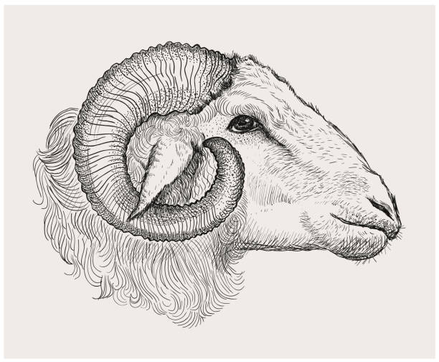
The entire beis medresh was silent as the Rebbe and the chassid had this exchange. Then the Rebbe said to all his chassidim, "No matter how many times you fall, just get up and try again. There is no choice. There is no other way."
For example, if a person is trying to refrain from speaking lashon hara, and he fails, he should try to be careful the next time. And if he is trying to overcome his anger, and he became angry, he should make another resolve to be calm and collective. Keep on trying, because trying is the purpose. That is called winning the battle against the yetzer hara.
We use the horn of an ram [an adult sheep] for a shofar. As the Shulchan Aruch states, "It is best when the shofar of Rosh Hashanah is from an… although all shofros are kosher…" (586:1).
The Gemara asks, “Why do we blow shofar with a ram's horn? Hakadosh Baruch Hu says, ‘Blow for Me with a ram’s shofar so I will remember Akeidas Yitzchok, and I will consider it as though you were bound on the akeidah before Me’” (Rosh Hashanah 16).
Avraham Avinu sacrificed by the akeidah, and therefore we use the shofar, to arouse this fond memory in heaven. We can ask, if the purpose of the shofar is to remind heaven of akeidas Yitzchak, any part of the ram would do? For example, the Torah could tell us to take a foot of the ram, or any other limb. Why is the mitzvah specifically to blow shofar?
The answer is, by the akeidah it's written, “Avraham raised his eyes and he saw that behold there was a ram; its horns were entangled in a bush” (Bereishis 22:13). The ram struggled to escape, but its horns were caught in the bush, and it couldn’t get out.
The shofar therefore represents challenges and struggles, and the shofar was therefore chosen for the mitzvah, because Hashem desires the struggle. If avodas Hashem would be simple and easy, there wouldn’t be reward, and our service wouldn't be spectacular. But because of the struggle, our avodas Hashem is precious to Hashem. There are times that we fail —it's only natural that we don’t succeed at times — but the goal and success, is when we keep on trying, again and again.

Reb Yitzchok Hutner zt'l wrote the following (in a letter): "We have a problem: When we discuss tzaddikim, we look at the final results, the accomplishments they achieved, the heights they reached, and we skip over their struggles, the times they had great conflicts with their nature and with the yetzer hara.
We have the impression that these tzaddikim were born tzaddikim. Everyone praises the Chofetz Chaim for his caution never to speak lashon hara. But who knows about all the battles, struggles, and even the failures and disappointments that he endured, as he fought the yetzer hara [until he reached his perfected, high level].
This is merely one example, among the thousands…. My request is, when you think of tzaddikim, don’t think that they were always at peace with their yetzer tov. See them standing in a great battlefield, with hardships and letdowns. When the yetzer hara is storming within you, know that at these times you are very similar to the tzaddikim whom you seek to emulate... Specifically in the areas where you fail the most, you have the potential to sanctify Hashem's name."

A Broken A Broken Heart The Baal Shem Tov taught his student, the Toldos Yaakov Yosef zy'a, the kavanos (kabalistic thoughts) that he should have by tekiyas shofar (when he called out the tekiyos). But on Rosh Hashanah, the Toldos forgot everything. He came to the tekiyos with a broken heart, and was crying the entire time, because he had forgotten everything. Later, the Baal Shem Tov told him, "The kavanos (kabalistic thoughts) are keys that open doors. Each kavanah opens a different door. But a broken heart opens up all doors."

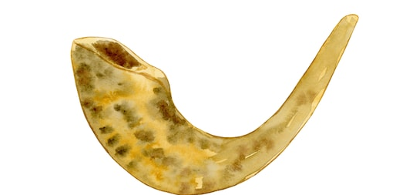

The Kedushas Levi zy'a once raised his shofar, and said to the women in the women section, "The shofar needs a rinsing," and they all began to cry. The baal makri (the one who calls out tekiyah, shevarim, etc.) asked my grandfather, Rebbe Dovid Biderman zy'a, what kabalistic kavanos he should have when he calls out the tekiyos. Rebbe Dovid Biderman replied, "I don’t know kavanos and you also don’t know. But one kavanah I will tell you. The shevarim is a small broken heart, and truah is a big broken heart…"

Reb Velvel Eisenbach zt'l was from the elders of Yerushalayim. (He was over a hundred years old and was niftar a few years ago on Rosh Hashanah .) He repeated what he heard from his grandfather, who heard it from his grandfather – to whom the story happened.
This grandfather (Reb Velvel Eisenbach's great-great grandfather) was by Rebbe Ahron Chernobler zy'a for Rosh Hashanah, when he was but a child. He was davening on the balcony (which was built special for Rosh Hashanah, to hold the many guests who came for Yom Tov).
It was extremely crowded and the child fainted. People threw water on him and revived him and brought him to the large opening in the floor, which opened to the beis medresh below, so he would have air. Lying there, he was able to watch Rebbe Ahron Chernobler approach the bimah for tekiyas shofar. He was also able to hear the vort that Rebbe Ahron Chernobler said before the tekiyos.
The rebbe said, "It is written (Tehillim 47): Elokim represents middas hadin (strict justice and punishment). It is raised and removed with äòåøú, with a broken heart. represents middas harachamim, Hashem's mercy. This can also depart, chas veshalom, when one thinks that everything is well, and he isn't worried at all." When the rebbe said this, the entire community cried. The child became wet once again, this time from their tears.

Reprinted from the 5777 Rosh Hashanah email of Torah Wellsprings: The Torah Insights of Rabbi Eli Biderman.

Eli Whitney's Rosh
Hashanah Resolution
By Rabbi Leiby Burnham

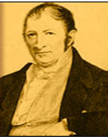
Eli Whitney
This Rosh Hashanah make sure your resolutions are S.M.A.R.T.

As Rosh Hashana rapidly approaches, we want to make resolutions that will help us change our lives for the better so that we don't make the coming year a repeat of this past year.
We can learn some important lessons about implementing change from Eli Whitney, a man who changed America and the entire world, more dramatically than Henry Ford or Alexander Graham Bell. A man who also made some fatal errors, ones that would cost him dearly.
Eli Whitney, a real Yankee from Massachusetts, graduated from Yale University in 1792, and moved south to fill a tutoring position which was supposed to assist him in paying off his college loans (some things never change). When he arrived, he found the employers would only pay half of what they had promised (again, some things never change). He left, and went looking for other work. He was invited to stay a week at a plantation outside of Savannah, while he went job-hunting.
At the plantation, he noticed a problem with Upland Cotton, the species commonly grown in the South. It had seeds covered in a coating resembling green velvet which stuck to the cotton fibers like Velcro. It took a full day of labor to "gin," or remove, the seeds from one pound of cotton. This was so inefficient that Upland Cotton was essentially worthless and the entire South was only exporting a few hundred bags of cotton to England each year.
Eli invented a machine called the cotton gin, which ginned cotton and cleaned itself. The South soon changed from an uncultivated wilderness to a wealthy blossoming agrarian region, eventually exporting as much as 920 million pounds of cotton to England each year.
This did not liberate the slaves; au contraire, slavery boomed, with the price of slaves rising from $50 in 1800 to $1,000 by 1850. However, the price of cloth dove down 99%, and people worldwide were clothed in comfortable, washable clothing. Even the common man could own more than one set of clothing for the first time in history.
But Eli didn't strike it rich. What was his big mistake? He tried to grab too big a piece of the pie. Recognizing the enormous benefit of his invention, he decided to set up his own cotton ginning centers where he charged farmers 40% of their crop. The Southerners found this ridiculous, especially coming from a Yankee, and began making their own crude cotton gins, waving a big thumb at Eli Whitney's patent. They even began a rumor that his machines were inferior, and soon factories in England wouldn't buy cotton ginned in his machines. He fought patent battles for years and ended up losing money on this world-altering invention.
Lesson #1: Every year we are tempted to make the coming year "the Big Year," when we fix all our bad habits. We're going to quit smoking, come home from work no later than 5:30 pm, go to synagogue daily, begin learning with a study partner once a week, and never say anything negative to anyone.
Let's learn from Eli. We may have the ideas for great innovations and positive changes, but we need to moderate them to ensure they will be doable. We can't bite a bigger piece than we can chew. In Social Work school, we learned the S.M.A.R.T. way to make goals; make them Specific, Measurable, Attainable, Realistic, and Time-Based. Just think where we'd be in 20 years from now if every year we were to take on one S.M.A.R.T. goal and actualize it.

Eli Strikes Back
After losing money on his gin, Eli needed cash, so he invented the system called mass production. Until then, most items were made beginning to end by one master craftsman, thus making every piece unique. If one part broke, the whole thing was useless. The U.S. Army was having a particularly difficult time manufacturing muskets. They took days to make, were expensive and, if one piece broke on the battlefield, the musket was useless, and the soldier became a sitting duck.
Eli invented a new system using high precision tools to manufacture parts. These parts could be assembled by any unskilled worker, and were entirely interchangeable. Thus, if a trigger were to break, a foot soldier would simply pull out a spare trigger and get back into action. The format Eli invented for the musket was adopted all over the world, revolutionizing manufacturing. Your car, washing machine, shaver, laptop, and bicycle are cheaper, easier to fix, and better as a result. Eli finally struck it rich.
Lesson #2: The problem Eli set out to fix can beset any of us. We often make resolutions which are complex and dependant on many factors. Here's one example: If I get up an hour earlier every day, and pray and exercise immediately after waking, then I'll be able to make my family a hot breakfast, and spend quality time with my kids before they go to school. That kind of resolution is dependant on far too many factors – if one detail breaks (you sleep through the alarm, your workout takes longer than expected, or one of your kids refuses to get out of bed), the entire resolution falls apart.
An example of a better resolution would be, "Every evening I will spend five minutes reviewing my day. I will make note of both the good things that should be repeated the next day, and the mistakes that should not." This is something that doesn't require other people's cooperation, it can be done anywhere, and at anytime in the evening, and if you miss one day you can be right back on track the next day.
Let's make sure our resolutions can be easily fixed if we slip, resolutions that can help us mass produce good deeds, and a happy life.

Reprinted from the September 16, 2006 website of Aish.com
How Sweet it is
By Sandy Eller

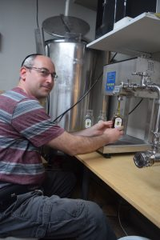

It seems as if it wasn’t all that long ago that Rosh Hashanah honey came in two basic varieties. Golden Blossom was sold in the jar with its iconic green and gold label, and store brand honey bore the name of whatever establishment you happened to be patronizing at that particular point in time.
As time went on, honey started showing up in those cute little plastic bear squeeze jars and in bottles bearing the names of just about every major kosher food company.
But today, honey is most definitely having a moment. On a trip to our local kosher supermarket two weeks before Rosh Hashanah I was greeted by a massive honey display. There was honey in shades ranging from gold to nearly black and even blue. There was honey packed in skinny straws, gift sets and decorative bottles.
There was raw honey still in the comb and honey in flavors like raspberry, mesquite, and avocado. I’ll tell you one thing – this definitely wasn’t the honey of my childhood – which now that I think about it, is perfectly fine with me.

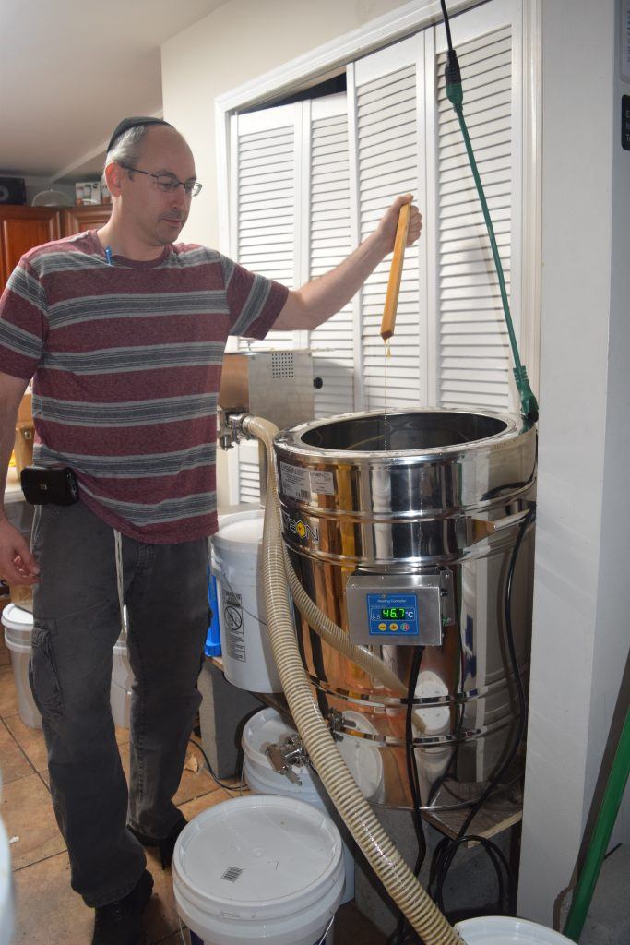

Getting Buzzed
It goes without saying that a discussion about honey is going to have to include some talk about bees, although it seems fair to say that most of us have made it a habit to avoid those buzzing, winged creatures. Although honeybees do us a tremendous service, providing the honey that graces Rosh Hashanah tables far and wide while also pollinating more than a few varieties of fruit and nuts, they do come with those pesky, pointy stingers, which led me to believe that any rational human being would do their best to avoid bees.
That assumption proved to be wrong, however, when I spoke to two completely sane individuals who spend considerable amounts of their spare time not only working with bees, but also protecting them in order to reverse a trend that has the honeybee population dwindling rapidly each year.

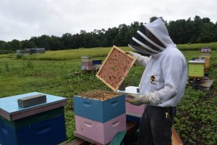

Rabbi Daniel Senter is the chief operating officer of Kof-K Kosher whose hobbies run the gamut. A magician and an EMT who is certified as both a mohel and a shochet, he also enjoys restoring cars, brewing beer, foraging, and homesteading. According to Rabbi Senter’s official bio, he lives in both Teaneck and Woodridge, New York with “his wife, five children, four goats, a dozen chickens, and a few million bees.”
Rabbi Senter’s fascination with bees began approximately eight years ago when a friend who had a farm in upstate Dutchess County needed some help with a mobile chicken coop. Paying a visit in order to lend a hand, Rabbi Senter noticed a stack of wooden boxes and a chain link fence. Swarms of bees were flying in and out of the boxes and over the fence.
“I asked him what it all was and he told me ‘those are my bees,’” recalled Rabbi Senter. “I told him he was crazy and then asked what the fence was for. That one, he told me, was to keep the bears away.”
The sight was so intriguing that Rabbi Senter found himself taking on yet another project, and he started researching bees, buying his first hive the following spring. Today, he has more than 100 hives in various locations in upstate New York, Manhattan, and New Jersey. And in what can only be described as the ultimate irony, Rabbi Senter discovered the hard way that he was allergic to bee stings. His reaction is thankfully, not life threatening, but still fairly extreme.
“I blew up like a balloon and my kids told me I look like the Michelin Man,” said Rabbi Senter.
Unwilling to give up on his honeybees, Rabbi Senter takes monthly allergy shots and he goes out of his way to be ultra-cautious as he tends to his hives. While the average person might find the thought of thousands of bees unnerving, Rabbi Senter finds interacting with bees to be extremely relaxing. He even teaches beekeeping to high schoolers.
“We suit up and the kids are away from any technology,” explained Rabbi Senter. “There are no cell phones and no texting and after our 45 minutes, not a single kid in the group can tell you what time it is. They get lost in what they are doing. It’s back to the basics; just you and the bees.”

LIQUID GOLD
Approximately 80 pounds of honey have to remain in the hive over the winter for bees to survive in our area, but the remainder is available for harvesting. Rabbi Senter estimated that he has already gotten 2,000 pounds of honey this year, with at least another thousand still waiting to be collected from his hives. Over the years, Rabbi Senter has sold his honey at the Teaneck farmer’s market and through direct sales, and he has also filled orders for schools and institutions who use it for pre-Rosh Hashanha gifts and fundraisers. Rabbi Senter saves a portion of his honey harvest for people with allergies who find the pollens that are present in local honey help them build up their immunity to those allergens that are in the air.
Having always assumed that honey was produced from pollens on low-lying plants like clover and alfalfa, I was surprised to learn that it can also be derived from flowering trees.
Rabbi Senter’s favorite honey is a late spring variety with a mild flavor that comes from the flowers of the black locust tree, with apple, basswood, and Japanese knotwood proving to be good sources of honey as well. Always happy to share his passion of bees with others, Rabbi Senter has mentored other would be beekeepers including Monsey resident Zev Oster who, over the past four years, has worked his way up to approximately 100 hives, scattered throughout Rockland County. Like Rabbi Senter, Oster is all in when it comes to bees and honey – the license plate on his SUV reads “ILUVBEES” and a decorative beehive dangles from his mailbox.
Oster harvested his first honey in 2016, walking away with 30 pounds of the sweet stuff. Having acquired many more hives over the years, also a certain percentage are lost every winter, Oster was rewarded this year with 2,700 pounds of honey. All of it was extracted from the hives from May to mid-July, an effort that involved blood, sweat and tears.
“It was a tremendous amount of work and I got up at 6:30 in the morning before it got too hot,” said Oster. “By 9:30 or ten o’clock it just wasn’t possible to work out there anymore most days because of the heat and I went back out after work, staying out until 9 P.M. checking on the hives.”

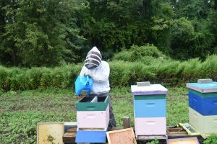

Oster bottles his product under the Rockland Honey label, topping each bottle with a beeswax seal from his hives, often staying up until 3 A.M. bottling honey during the busy season. The honey he harvests is labeled simply as local honey, without no particular variety specified, because there is no way to know exactly what plants the bees are getting their pollen from.
“If you have hives in an area that is surrounded by nothing but acres and acres of blueberries, then you know that it is blueberry honey, but here we can’t say for sure exactly what kind of honey our bees are producing,” explained Oster, who is also experimenting with honey made from goldenrod which flowers in September, further extending the honey season.
In addition to its Monsey-area honey, Rockland Honey sells a wide variety of products brought in from other honey producers throughout the United States. Oster’s products are available online and in stores in Monsey and beyond and include more than ten flavors of pure raw honey and honey sticks in fruity, floral, sour and exotic flavors such as watermelon, pink lemonade, pina colada and chocolate. Like Rabbi Senter, Oster’s favorite honey flavor is also derived from the pollen of a tree I have never even heard of – tulip poplar.
While many Jewish families have small kitchens in their basements that are designated for Pesach preparations, the Oster’s downstairs kitchen is used exclusively for honey. This year’s bountiful harvest has had Oster tweaking his operations, moving his extraction equipment into the garage, while the bottling remains in the basement, a change that meant that Oster had to move hives that had previously been in his backyard to another location.

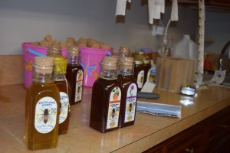

“Once we were spinning the honey in the garage, we couldn’t keep the bees in the backyard anymore,” said Oster. “In ten minutes, we could have had hundreds of thousands of bees in the garage, which would have been a big problem.”
Some of Oster’s hives are quite a sight to see, housed in colorfully painted boxes that are anything but typical. There is one painted to look like a police station, another done in a Kosel motif, and in a Trumpian reference, one bearing the words “Make America Sweet Again.” I took advantage of an opportunity to see them up close, maybe a little closer than I might have liked, after taking Oster up on an invitation to see the bees, donning a bee jacket, complete with an attached hood and veil that covered my entire face. It definitely wasn’t one of my finest fashion moments and thankfully there are no pictures to document that particular episode of my career as a writer.

HONEY, WE HAVE A PROBLEM
We take it for granted that there will always be honey on our Rosh Hashanah tables, but honeybees have been mysteriously dying out for quite a while. According to Newsday, 80 to 90 percent of the honeybees in central Maryland died from the summer of 2017 to the spring of 2018 and a report that appeared in Business Insider estimated that 10 million of the 83 million of the world’s beehives were lost in the year 2014 alone.
The jury is still out on the reasons for those losses, which affect not only honey production but other items pollinated by bees including apples, peaches, plums, nectarines, strawberries, and almonds.
“The plight of the honeybee is very concerning,” said Rabbi Senter. “They are disappearing in record numbers and it could be due to a number of factors including loss of habitat, a parasite called the Varroa mite, or pesticides.”
Thankfully, interest in beekeeping has been growing steadily and Oster is just one bee enthusiast who took up the hobby after hearing the honeybee population was declining, doing his part to bolster the honeybee population. In addition to expanding his hives every year, Oster founded the Rockland Bee Club several years ago, with 15 to 20 people turning out at every monthly meeting. Several parties have reached out to Oster and offered to let him put hives on their land, including the mayor of Haverstraw, a town located northwest of Monsey.
“It’s good publicity,” remarked Oster who has hives on a ramp to a heavily traveled local roadway. “People beep and they stop and get out of their cars and ask questions. They are really fascinated by it.”
Rabbi Senter notes that while honeybees may be in trouble, it’s not all doom and gloom for our little winged friends. Scientists have been working hard to solve the mystery of what is known as colony collapse disorder, with Israel leading the pack on pioneering research in the field. Citing a five-tiered approach that includes improving honeybee health and nutrition, preserving and restoring their environment, combatting disease, eliminating harmful pesticides and promoting awareness, Rabbi Senter expressed his hope that we will be able to enjoy our apples in dipped in honey for many years to come.
What kind of honey will grace your Rosh Hashanah table this year? It seems like this year there are more flavors to choose from than ever before. As for me, I’ll be polishing up my honey dish and pulling out a jar of vanilla creamed honey that I got as a gift. And of course, there is going to have be a plastic honey bear somewhere on my table at some point in time over the Yom Tov season. Some traditions are just too sacred to tamper with.

Reprinted from the Rosh Hashanah 2019 edition of the Jewish Echo.

